Pollinator Habitat Plan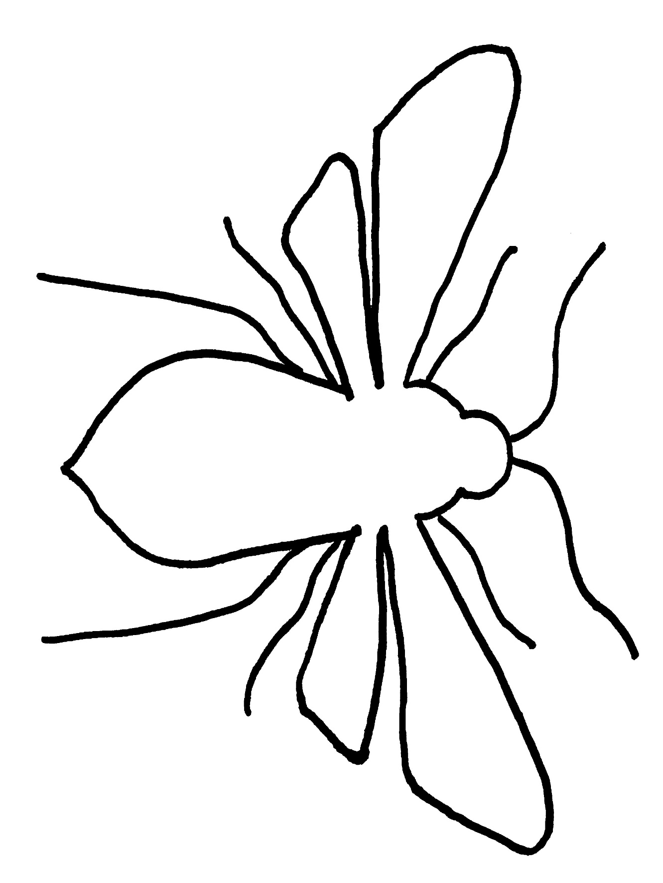
Trellis
Saucer
Saucer
Bare Soil
Bare Soil
FF FF FF
SPE SPE SPE
HW HW HW
WP WP WP
C C C
Stepping Stones
M M M
B B B
AW AW AW
SHM SHM SHM
SM SM SM
V V V
Trellis
CH CH CH
H H H
Trellis
Trellis
Trellis
Trellis
Sticks or Stones
Sticks or Stones
Sticks or Stones
Sticks or Stones
Sticks or Stones
Sticks or Stones
CA CA CA
YP YP YP
SB SB SB
PP PP PP

Planting Guide:
- This pollinator habitat plan can be adapted to fit any size area.
- Plant each species in multiples of three for best effect.
- Mulch around the plants with organic matter.
- Leave bare ground for nesting bees.
- Add trellises to support vines. Trellises can be as simple as bamboo sticks.
- Use sticks or stones to outline the pollinator habitat.
- Water in well and continue until plants are established.
- Weed as needed.
- Fill the sauce with damp sand for a puddling place for butterflies.
- Stepping stones provide access to the pollinator habitat.
Key:
Caterpillar Food Sources
- Sandhills Milkweed: SHM
- Scarlet Hibiscus: SH
- Canna: C
- Blazing Star: BS
- Purple Passionflower: PP
- Butterflyweed: B

Nectar Sources:
Spring
- Herb William: HW
- Violet: V
- American Wisteria: AW
- Milkpea: M
Summer
- Swamp Milkweed: SM
- Wild Petunia: WP
- Coral Honeysuckle: CH
- Spurred Butteflypea: SB
- Giant Ironweed: GI
Fall
- Yellow Passionflower: YP
- Spoonleaf Purple Everlasting: SPE
- False Foxglove: FF
- Climbing Aster: CA

